001 SAP HANA Agile Data Mart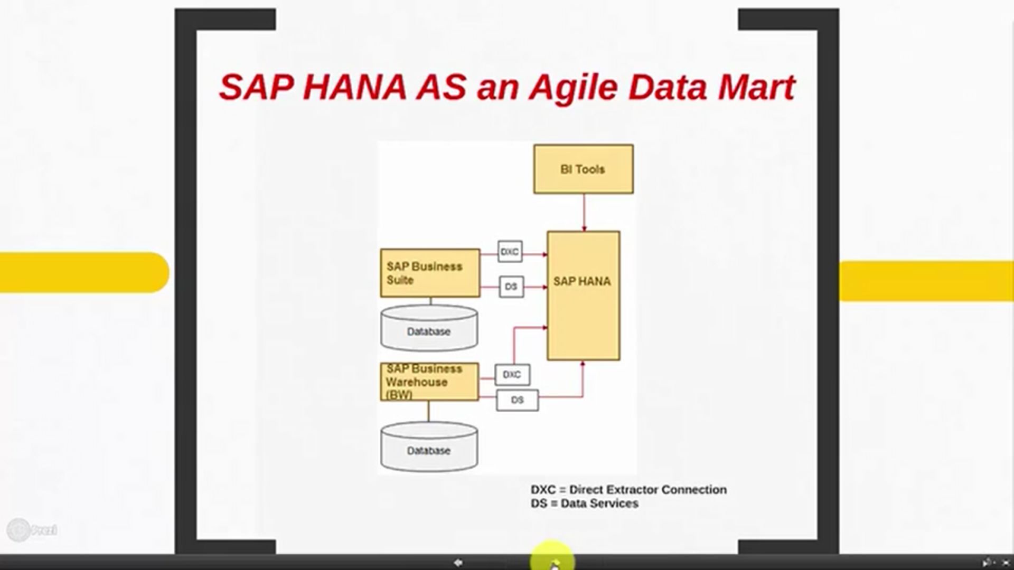

Data mart is a repository where data is gathered from different transactions, once it is gathered a semantics layer is created on top of it and user use this information to create different reports and use that for various other reasons.